1. Old Friends, Good Friend

More than 30 years ago, when I took my first job in New York City, I found myself working with a number of young women. Some I got to know just in passing, but others gradually became my friends. Today, six of these women remain an important part of my life. They are more than simply friends, more even than close friends. They are old friends, as indispensable as sunshine and more dear to me than ever. These people share a long-standing history with me. In fact, old friends are a lot like promises. They put reliability into the uncertainty of life and establish a reassuring link between the past, present, and future. The attachment between friends who have known each other for many years is bound to be complex. On occasion we are exceedingly close, and at other times one or both of us invariably step back. Ebb and flow. Thick and thin. How smoothly and gently we negotiate these hills and valleys .has everything to do with how well the friendship ages.Sometimes events intervene in a way that requires us to rework the term of a relationship. A friend starts a second career, let’s say, and suddenly has less free time.Another remarries, adding someone new to the equation. Talk honestly and listen to each other to find out if the other’s needs are being met. Renegotiating pays full tribute to life’s inevitable changes and says that we deem our friendships worthy of preserving.Old friends are familiar with the layers of our lives. They have been there in the gloom and the glory. Even so, there’s always room to know more about another person. Of course, self-disclosure can make even old friends more vulnerable, so go slowly: Confiding can open new doors, but only if we knock first.Time is the prime commodity between old friends.by this I mean the time spent doing things together. Whether it’s face to face over a cup of coffee, side by side while jogging, ear to ear over the phone, or via email and letters, don’t let too much time go by without sharing your thoughts with each other.

1. Why I Want a Wife

I belong to that classification of people known as wives.I am A Wife. And, not altogether incidentally,I am a mother. Not too long ago a male friend of mine appeared on the scene fresh from a recent divorce. He had one child, who is, of course, with his ex-wife. He is looking for another wife. As I thought about him while I was ironing one evening,it suddenly occurred to me that I, too, would like to have a wife. Why do I want a wife?I would like to go back to school so that I can become econmically independent,support myself, and if need be,support those dependent upon me. I want a wife who will work and send me to school. And while I am going to school I want a wife to take care of my children. I want a wife who take care of my physical needs.I want a wife who will keep my house clean. I want a wife who cooks the meals, a wife who is a good cook. I want a wife who will plan the menus, do the necessary grocery shopping, prepare the meals, serve them pleasantly, and then do the cleaning up while I do my studying.I want a wife who will care for me when I am sick and sympathize with my pain and loss of time from school. I want a wife who will not bother me with rambling complaints about a wife’s duties.But I want a wife who will listen to me when I feel the need to explain a rather difficult point I have come across in my course of studies.And I want a wife who will type my papers for me when I have written them. When I am through with school and have a job ,I want my wife to quit working and remain at home.so that my wife can more fully and completely take care of a wife’s duties.If, by chance, I find another person more suitable as a wife than the wife I already have,I want the liberty to replace my present wife with another one.Naturally, I will expect a fresh, new life. my wife will take the children and be solely responsible for them so that I am left free.

My god, who wouldn’t want a wife?

Book and Life

Books are to mankind what memory is to the individual. They contain the history of our race, the discoveries we have made, the accumulated knowledge and experience of ages; they picture for us the miracles and beauties of nature, help us in our difficulties, comfort us in sorrow and in suffering, change hours of weariness into moments of delight, store our minds with ideas, fill them with good and happy thoughts, and lift us out of and above ourselves.Many of those who have had, as we say, all that this world can give, have yet told us they owed much of their purest happiness to books. Macaulay had wealth and fame, rank and power, and yet he tells us in his biography that he owed the happiest hours of his life to books. He says, “If any one would make me the greatest king that ever lived, with palaces and gardens and fine dinners, and wines and coaches, and beautiful clothes, and hundreds of servants, on condition that I should not read books, I would not be a king; I would rather be a poor man in a garret with plenty of books than a king who didn’t love reading.”Precious and priceless are the blessings which the books scatter around our daily paths. We walk, in imagination, with the noblest spirits, through the most solemn and charming regions.Without stirring from our firesides we may roam to the most remote regions of the earth, or soar into realms when Spenser's shapes of unearthly beauty flock to meet us, ]where Milton's angels peal in our ears the choral hymns of Paradise. Science, art, literature, philosophy, —all that man has thought, all that man has done, the experience that has been bought with the sufferings of a hundred generations,all are garnered up for us in the world of books.

1. The Road to Happiness

If you look around at the men and women whom you can call happy, you will see that they all have certain things in common.The most important of these things is an activity which at most gradually builds up something that you are glad to see coming into existence. Women who take an instinctive pleasure in their children can get this kind of satisfaction out of bringing up a family. Artists and authors and men of science get happiness in this way if their own work seems good to them. But there are many humbler forms of the same kind of pleasure. Many men who spend their working life in the city devote their weekends to voluntary and unremunerated toil in their gardens, and when the spring comes, they experience all the joys of having created beauty.

The whole subject of happiness has, in my opinion,been treated too solemnly.It had been thought that man cannot be happy without a theory of life or a religion. Perhaps those who have been rendered unhappy by a bad theory may need a better theory to help them to recovery,

just as you may need a tonic when you have been ill. But when things are normal a man should be healthy without a tonic and happy without a theory. It is the simple things that really matter.

If a man delights in his wife and children, has success in work, and finds pleasure in the alternation of day and night, spring and autumn, he will be happy whatever his philosophy may be. If, on the other hand, he finds his wife fateful, his children’s noise unendurable, and the office a nightmare; if in the daytime he longs for night, and at night sighs for the light of day, then what he needs is not a new philosophy but a new regimen—a different diet, or more exercise, or what not.Man is an animal, and his happiness depends on his physiology more than he likes to think.

This is a humble conclusion, but I cannot make myself disbelieve it. Unhappy businessmen, I am convinced,would increase their happiness more by walking six miles every day than by any conceivable change of philosophy.

(5) A Little Girl

Sitting on a grassy grave, beneath one of the windows of the church, was a little girl. With her head bent back she was gazing up at the sky and singing, while one of her little hands was pointing to a tiny cloud that hovered like a golden feather above her head. The sun, which had suddenly become very bright, shining on her glossy hair, gave it a metallic luster, and it was difficult to say what was the color, dark bronze or black. So completely absorbed was she in watching the cloud to which her strange song or incantation seemed addressed, that she did not observe me when I rose and went towards her. Over her head, high up in the blue, a lark that was soaring towards the same gauzy cloud was singing, as if in rivalry. As I slowly approached the child, I could see by her forehead, which in the sunshine seemed like a globe of pearl, and especially by her complexion, that she uncommonly lovely. Her eyes, which at one moment seemed blue-gray, at another violet, were shaded by long black lashes, curving backward in a most peculiar way, and these matched in hue her eyebrows, and the tresses that were tossed about her tender throat were quivering in the sunlight. All this I did not take in at once; for at first I could see nothing but those quivering, glittering, changeful eyes turned up into my face. Gradually the other features, especially the sensitive full-lipped mouth, grew upon me as I stood silently gazing. Here seemed to me a more perfect beauty than had ever come to me in my loveliest dreams of beauty. Yet it was not her beauty so much as the look she gave me that fascinated me, melted me.

(1)

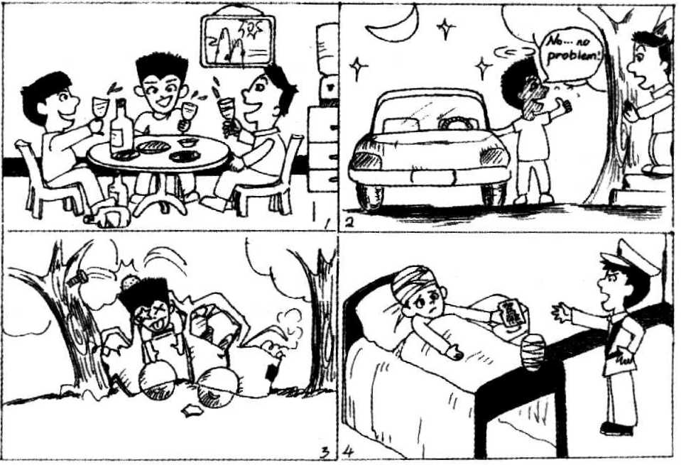

(2)



(3)



(4)

